

DATA AND DISTRIBUTED SYSTEMS
COMP40051
DATA DOCUMENTATION
David Ayelagbe
25019606
4th May 2026.
PART B –

Role Assigned – ASSISTANT.

- ERD Diagram

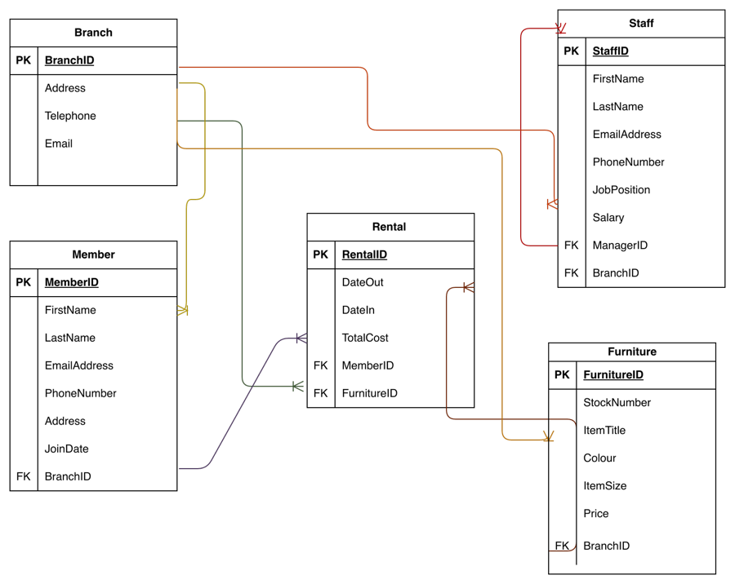
Entities
Branch
Staff
Member
Furniture
Rental
Relationships
They all make use of the 1 to Many relationship,
. Branch -> Staff, therefore, uses the 1 to Many relationship.
. Branch -> Member, therefore, uses the 1 to Many relationship.
. Branch -> Furniture, therefore, uses the 1 to Many relationship.
. Branch -> Rentals, therefore, uses the 1 to Many relationship.
. Member -> Rentals, therefore, uses the 1 to Many relationship.
. Furniture -> Rentals, therefore, uses the 1 to Many relationship,
. Staff -> Staff -> uses the 1 to Many relationship, because a Manager can manage many Staffs.

Attributes to their associated Entities.
Branch
. PK – BranchID,
. Address,
. Telephone,
. Email.
Staff
. PK – StaffID,
. FirstName,
. LastName,
. EmailAddress,
. PhoneNumber,
. Position,
. Salary,
. FK – ManagerID,
. FK – BranchID.
Member
. PK – MemberID,
. FirstName,
. LastName,
. EmailAddress,
. PhoneNumber,
. Address,
. JoinDate,
. FK – BranchID.
Furniture
. PK – FurnitureID, uniquely identifies each record.
. StockNumber,
. ItemTitle,
. Colour,
. Size,
. Price,
. FK – BranchID.
Rental
. PK – RentalID,
. DateOut,
. DateIn,
. TotalCost,
. FK – MemberID,
. FK – FurnitureID.
Keys
Primary Key(s) (PK) Foreign Key(s) (FK)
. BranchID, . ManagerID,
. MemberID, . BranchID,
. StaffID, . MemberID,
. FurnitureID, . FurnitureID.
. RentalID,

Constraints Used
. PK -> Unique Identifier to identify each row such as BranchID, StaffID, MemberID, FurnitureID, RentalID and other important fields such as the names, phone, email, position, salary, etc.
. FK -> Reference to another table such as BranchID, ManagerID, MemberID and FurnitureID.
. NOT NULL, -> all Entities must have a value and can’t be empty except for things like color.
. CHECK constraints -> Salary, Price, and Total Cost must be greater than 0 because in instance a salary can’t be negative.
. SEQUENCE -> to automate creation of new PK values instead of inputting manually.

- SQL

CREATE TABLE BRANCH (
BranchID VARCHAR2(6) PRIMARY KEY,
Address VARCHAR2(100) NOT NULL,
Telephone VARCHAR2(12) NOT NULL,
Email VARCHAR2(50) NOT NULL
);

CREATE TABLE MEMBER (
MemberID VARCHAR2(8) PRIMARY KEY,
FirstName VARCHAR2(20) NOT NULL,
LastName VARCHAR2(20) NOT NULL,
EmailAddress VARCHAR2(50) NOT NULL,
PhoneNumber VARCHAR2(20) NOT NULL,
Address VARCHAR2(100) NOT NULL,
JoinDate DATE NOT NULL,
BranchID VARCHAR2(6) NOT NULL,
FOREIGN KEY (BranchID) REFERENCES Branch(BranchID)
);

CREATE TABLE Staff (
StaffID VARCHAR2(7) PRIMARY KEY,
FirstName VARCHAR2(20) NOT NULL,
LastName VARCHAR2(20) NOT NULL,
EmailAddress VARCHAR2(50) NOT NULL,
PhoneNumber VARCHAR2(20) NOT NULL,
JobPosition VARCHAR2(20) NOT NULL,
Salary Number(10) CONSTRAINT check_salary CHECK (Salary > 0),
BranchID VARCHAR2(6) NOT NULL,
ManagerID VARCHAR2(7),
FOREIGN KEY (ManagerID) REFERENCES Staff(StaffID),
FOREIGN KEY (BranchID) REFERENCES Branch(BranchID)
);

CREATE TABLE Furniture (
FurnitureID VARCHAR2(8) PRIMARY KEY,
StockNumber VARCHAR2(8) NOT NULL,
ItemTitle VARCHAR2(50) NOT NULL,
Colour VARCHAR2(8),
ItemSize VARCHAR2(10) CONSTRAINT check_itemsize CHECK (ItemSize IN ('KingSize', 'Small', 'Medium', 'Large')),
Price NUMBER(8) CHECK (Price > 0),
BranchID VARCHAR2(6) NOT NULL,
FOREIGN KEY (BranchID) REFERENCES Branch(BranchID)
);

CREATE TABLE Rental (
RentalID VARCHAR2(7) PRIMARY KEY,
DateOut DATE NOT NULL,
DateIn DATE NOT NULL,
TotalCost NUMBER(20) CONSTRAINT check_totalcost CHECK (TotalCost > 0),
MemberID VARCHAR2(8) NOT NULL,
FurnitureID VARCHAR2(8) NOT NULL,
FOREIGN KEY (MemberID) REFERENCES Member(MemberID),
FOREIGN KEY (FurnitureID) REFERENCES Furniture(FurnitureID)
);
COMMIT;

INSERT INTO Branch (BranchID, Address, Telephone, Email)
VALUES ('B010', '16, Castle St Eccleshall Stafford, Staffordshire, ST21 6DF', '01785850166', 'stafford@furniturehouse.com');

INSERT INTO Branch (BranchID, Address, Telephone, Email)
VALUES ('B011', '17, StokeCastle Stafford, Stoke, ST3 2DEF', '01785850166', ‘stoke@furniturehouse.com');

INSERT INTO Branch (BranchID, Address, Telephone, Email)
VALUES ('B012', '20, Benten longs, Longton, ST6 4AB', '01785850166', longton@furniturehouse.com');

INSERT INTO MEMBER (MemberID, FirstName, LastName, EmailAddress, PhoneNumber, Address, JoinDate, BranchID)
VALUES ('M12345', 'John', 'Green', 'johngreen@gmail.com', '07080804090', '16 Brockley Sq, Hanley, ST1 5LY', TO_DATE('12-12-2006', 'DD-MM-YYYY'), 'B010');

INSERT INTO MEMBER (MemberID, FirstName, LastName, EmailAddress, PhoneNumber, Address, JoinDate, BranchID)
VALUES ('M14234', 'Peter', 'Brown', 'peterbrown@gmail.com', '07770070084', '127 Pea Lane, Hanley, ST1 4JH', TO_DATE('13-12-2006', 'DD-MM-YYYY'), 'B010');

INSERT INTO MEMBER (MemberID, FirstName, LastName, EmailAddress, PhoneNumber, Address, JoinDate, BranchID)
VALUES ('M12432', 'Ron', 'Davis', 'rondavis@gmail.com', '07865432111', '83 York Street, Hanley, ST1 5ET', TO_DATE('13-12-2006', 'DD-MM-YYYY'), 'B010');

UPDATE Member
SET BranchID = 'B011'
WHERE MemberID = 'M14234';

UPDATE Member
SET BranchID = 'B012'
WHERE StaffID = 'M12432';

INSERT INTO MEMBER (MemberID, FirstName, LastName, EmailAddress, PhoneNumber, Address, JoinDate, BranchID)
VALUES ('M15234', 'Fred', 'Dawn', 'dawn@gmail.com', '07770549084', '127 Lane, Hanley, ST1 4OH', TO_DATE('13-12-2006', 'DD-MM-YYYY'), 'B011');

INSERT INTO MEMBER (MemberID, FirstName, LastName, EmailAddress, PhoneNumber, Address, JoinDate, BranchID)
VALUES ('M16234', 'Dext', 'Dew', 'dew@gmail.com', '07560070084', '17 Pea , Hanley, ST1 4LK', TO_DATE('13-12-2006', 'DD-MM-YYYY'), 'B010');
COMMIT;

INSERT INTO STAFF (StaffID, FirstName, LastName, EmailAddress, PhoneNumber, JobPosition, Salary, BranchID)
VALUES ('S0090', 'John', 'Green', 'johngreen@furniturehouse.com', '07123456789', 'Manager', 45000, 'B010');

INSERT INTO STAFF (StaffID, FirstName, LastName, EmailAddress, PhoneNumber, JobPosition, Salary, BranchID)
VALUES ('S0080', 'Lily', 'Mckenzie', 'lily@furniturehouse.com', '07135456789', 'Manager', 45000, 'B011');

INSERT INTO STAFF (StaffID, FirstName, LastName, EmailAddress, PhoneNumber, JobPosition, Salary, BranchID)
VALUES ('S0070', 'Reed', 'Jest', 'jest@furniturehouse.com', '07123458699', 'Manager', 45000, 'B012');

INSERT INTO STAFF (StaffID, FirstName, LastName, EmailAddress, PhoneNumber, JobPosition, Salary, ManagerID, BranchID)
VALUES ('S0110', 'Cal', 'Jones', 'caljones@furniturehouse.com', '07234567890', 'Administrator', 40000, 'S0090', 'B010');

INSERT INTO STAFF (StaffID, FirstName, LastName, EmailAddress, PhoneNumber, JobPosition, Salary, ManagerID, BranchID)
VALUES ('S0120', 'Clare', 'Smith', 'claresmith@furniturehouse.com', '07345678901', 'Administrator', 40000, 'S0090', 'B010');

INSERT INTO STAFF (StaffID, FirstName, LastName, EmailAddress, PhoneNumber, JobPosition, Salary, ManagerID, BranchID)
VALUES ('S1060', 'Chris', 'Logan', 'chrislogan@furniturehouse.com', '07456789012', 'Assistant', 23000, 'S0090', 'B010');

INSERT INTO STAFF (StaffID, FirstName, LastName, EmailAddress, PhoneNumber, JobPosition, Salary, ManagerID, BranchID)
VALUES ('S1070', 'Anne', 'Walters', 'annewalters@furniturehouse.com', '07456789012', 'Assistant', 23000, 'S0090', 'B010');

INSERT INTO STAFF (StaffID, FirstName, LastName, EmailAddress, PhoneNumber, JobPosition, Salary, ManagerID, BranchID)
VALUES ('S1080', 'Jan', 'Round', 'janround@furniturehouse.com', '07456789012', 'Assistant', 23000, 'S0090', 'B010');

INSERT INTO FURNITURE (FurnitureID, StockNumber, ItemTitle, Colour, ItemSize, Price, BranchID)
VALUES ('F1', '18828', 'Ikea malm bed', 'Brown', 'KingSize', 40, 'B010');

INSERT INTO FURNITURE (FurnitureID, StockNumber, ItemTitle, Colour, ItemSize, Price, BranchID)
VALUES ('F2', '16253', 'Habitat Kristopher Bed', 'Grey', 'Small', 30, 'B010');

INSERT INTO Rental (RentalID, DateOut, DateIn, TotalCost, MemberID, FurnitureID)
VALUES ('R10', TO_DATE('16-07-2022', 'DD-MM-YYYY'), TO_DATE('18-12-2022', 'DD-MM-YYYY'), 240, 'M12345', 'F1');

INSERT INTO Rental (RentalID, DateOut, DateIn, TotalCost, MemberID, FurnitureID)
VALUES ('R11', TO_DATE('19-07-2022', 'DD-MM-YYYY'), TO_DATE('20-01-2023', 'DD-MM-YYYY'), 210, 'M14234', 'F2');
COMMIT;

CREATE SEQUENCE furniture_seq
START WITH 3
INCREMENT BY 1
NOCACHE;

CREATE SEQUENCE rental_seq
START WITH 12
INCREMENT BY 1
NOCACHE;

INSERT INTO FURNITURE (FurnitureID, StockNumber, ItemTitle, Colour, ItemSize, Price, BranchID)
VALUES ('F' || furniture_seq.NEXTVAL, '17548', 'Coffee desk', 'White', 'Medium', 25, 'B010');

INSERT INTO Rental (RentalID, DateOut, DateIn, TotalCost, MemberID, FurnitureID)
VALUES ('R' || rental_seq.NEXTVAL, TO_DATE('11-01-2023', 'DD-MM-YYYY'), TO_DATE('15-12-2023', 'DD-MM-YYYY'), 220, 'M12432', 'F3');
COMMIT;

SELECT * FROM Branch;
SELECT * FROM Staff;
SELECT * FROM Member;
SELECT * FROM Furniture;
SELECT * FROM Rental;
These queries show that the table were populated correctly and are functioning as required.

- Constraints used are PK, FK, NOT NULL and CHECK
. PK constraints maps to BranchID, StaffID, MemberID, FurnitureID, RentalID,
Each record serves as a unique identifier for their respective tables.
. FK constraints
Staff uses FK BranchID Referencing Branch table,
Staff uses FK ManagerID Referencing Staff table because a manager can manage the whole
staff,
Rental uses FK MemberID Referencing Member table,
Rental uses FK FurnitureID Referencing Furniture table,
Member and Furniture use FK BranchID Referencing Branch.

. NOT NULL
Important fields cannot be empty, and this is used in Names, Address, Contacts, Dates, all
table ID’s, Stock Numbers, Prices, Positions, Salary.
. CHECK constraints
Only valid values are allowed
for instance CHECK Salary > 0 means, value must be greater and not lesser than 0.
**** screenshot of the errors found when the queries are violated when doing the insertions for PK, FK, NOT NULL, CHECK

PK

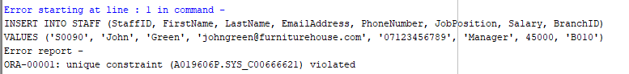

PK error of ORA-00001: shows Unique Constraint Violated, PK already exist

FK

Integrity constraints violated FK does not exist

NOT NULL
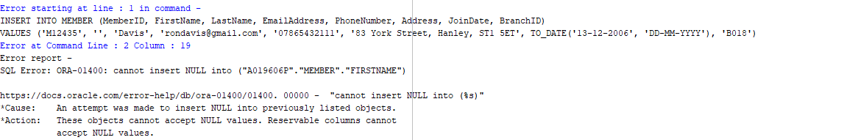

Cannot be empty, it must have a value in the FirstName field.

CHECK

CHECK Constraints violated, salary can’t be negative.

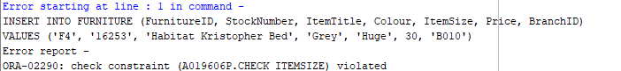

Likewise CHECK Constraints violated because of the item size Huge is not on the size list.

- Role – Assistant

You have been assigned one of the following roles:
Assistant

The queries required by each role are as follows:

Assistant:
- List all the Furniture for a user entered attribute e.g. colour, size etc (interactive SQL) (5 marks)
SELECT *
FROM Furniture
WHERE Colour = ‘&EnterColour';

SELECT *
FROM Furniture
WHERE itemsize = ‘&EnterItemSize';

SELECT *
FROM Furniture
WHERE ItemTitle = ‘&EnterItemTitle’;

- List all staff details for all staff with the same line manager as yourself (5 marks)

SELECT *
FROM Staff
WHERE ManagerID = ‘S0090’;

- List all Furniture in terms of branch and purchase date ( 5 marks)

SELECT Furniture.FurnitureID,
Furniture.ItemTitle,
Furniture.Price,
Furniture.BranchID,
Rental.DateOut
FROM Furniture
JOIN Rental
ON Furniture.FurnitureID = Rental.FurnitureID;

- Create an interactive query utilising the rank command in an appropriate manner for your assigned role. (15 marks)

Selecting furniture based on price
SELECT FurnitureID,
ItemTitle,
Price,
BranchID,
RANK() OVER (ORDER BY Price DESC) AS Price_Order
FROM Furniture
WHERE BranchID = '&EnterBranchID';

- You should design, implement, document and demonstrate a query demonstrating the application of the decode function in a manner appropriate to your assigned role. (20 marks)

SELECT FurnitureID,
ItemTitle,
Price,
BranchID,
DECODE(Price,
40, '£40 premium value',
30, '£30 Standard value',
25, '£25 Budgeted Value') AS PriceGBP,

DECODE(BranchID,
'B010', 'Eccleshall Branch',
'B011', 'Stoke Branch',
'B012', 'Longton Branch') AS Branches
FROM Furniture;

- Create a brief sql report demonstrating appropriate functionality for the assigned role. (20 marks)

A report showing the member id and name correlating to the furniture they rented listing the stock number and relevant details necessary to track the customer making the recent purchase as the first on the list or top of the list.
So it would be able to list the member details, list the furniture they rented as well as the date It was rented out, ranking by newest rental purchases.

SELECT Member.MemberID,
Member.Firstname,
Member.Lastname,
Member.Emailaddress,
Member.Branchid,

Furniture.Stocknumber,
Furniture.Itemtitle,
Furniture.Price,

Rental.DateOut,

RANK () OVER ( ORDER BY Rental. DateOut DESC) AS Recent_Purchase
FROM MEMBER

JOIN Furniture
ON Furniture.Furnitureid = Rental.Furnitureid

JOIN Rental
ON Member.Memberid = Rental.MemberID;

7). Create a multi-page, interactive sql report demonstrating use of views to present a summary style management information report suitable for the assigned role. (30 marks)
View makes things much easier to call later instead of writing select, from, on prompt every time.

As an assistant I would be using view prompt to show the summary for rental, by branch . This also prompts the user to given in the BranchID and returns the management info such as count, stock values and the price average.

CREATE VIEW Rental_Summary AS
SELECT Member.BranchID,
COUNT(Rental.RentalID) AS Total_Rentals,
SUM(Rental.TotalCost) AS Total_Revenue,
AVG(Rental.TotalCost) AS Average_Rental_Value
FROM Member
JOIN Rental
ON Member.MemberID = Rental.MemberID
GROUP BY Member.BranchID;

SELECT BranchID,
Total_Rentals,
Total_Revenue,
Average_Rental_Value
FROM Rental_Summary
WHERE BranchID = &EnterBranchID;

